Safe warning
1, Check supply voltage whether it matches the light engine
2,Prohibit to place the light engine under rain or wet spot, prevent from causing troubles or danger
of electronic shock
3,Light engine should be used in droughty surroundings, not stack other things around it

Iutput voltage | 12VDC | Power frequency | NONE
Quantity of LED | 1pcs | Color Control | 2.4G remote control
Color | RGBW | twinke wheel control | RF remote control
Life of LED | 50000H | Body size | L150*W150*H88MM  (without connector)
RED | 180LM | Gear | inside
Green | 360LM | LED brand | EPILEDS
Blue | 90LM | Connector diameter: | 30mm
White | 390LM | Operate temperature | -10-40°C
Max power | 27W | Body size | L150*W150*H88MM  (without connector)

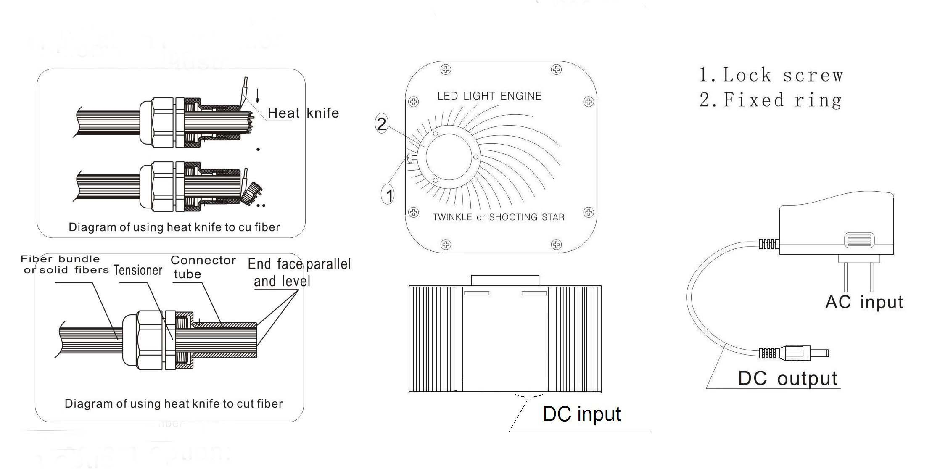

Color control(2.4G remote control)
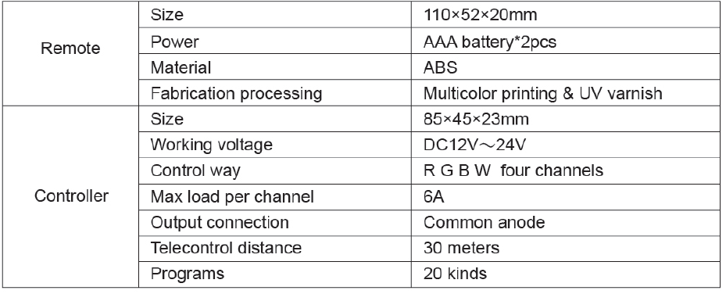
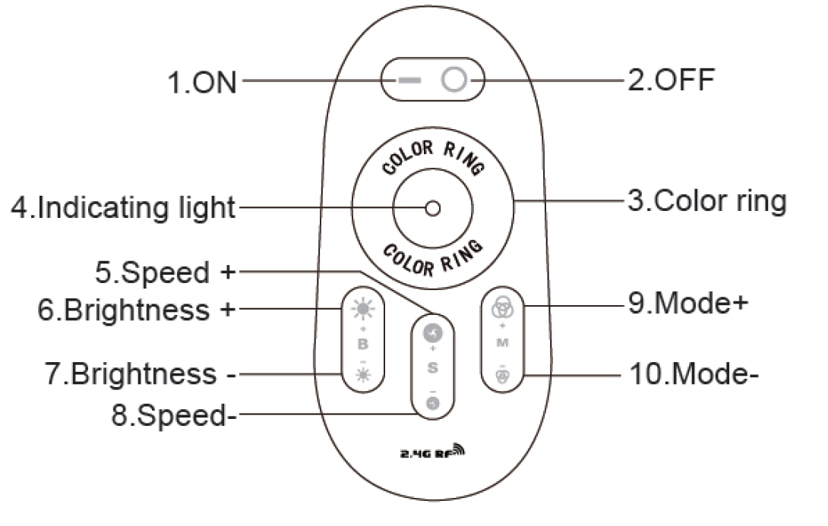
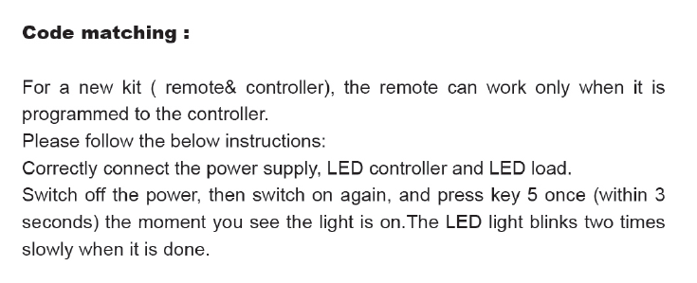

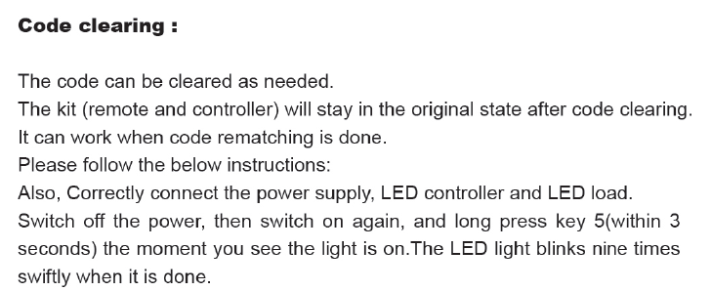
Color program list
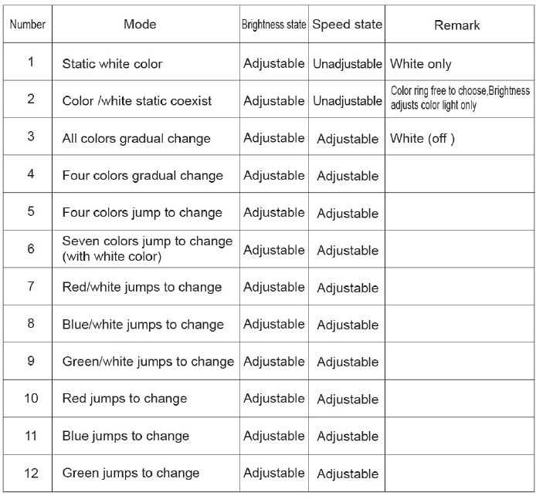
Twinkle wheel control(RF remote control)
